**Name: Bright Kofi Ladzro**

**Course Title:** [**DATA-413-001/006.2025S, DATA-613-001/006.**](https://american.instructure.com/courses/67913)

**Title:** **Git and GitHub Assignment**

1. Create a PDF Document with the following content:
   * Title: "Git and GitHub Assignment"
   * Your GitHub Repository URL:  
     Include the URL of your GitHub repository at the top of the PDF (e.g., https://github.com/your-username/git-clone-push-assignment).
   * Screenshots and Git Commands:
     + For each of the steps (cloning, adding a file, staging, committing, pushing), include a screenshot of the terminal and the corresponding Git commands and their outputs.
     + Make sure each screenshot is clearly labeled and explained.
   * Make sure the PDF is properly formatted and easy to follow.

**Git Bash Cloning of a Repository**

In Git, cloning is making a local copy of a remote repository available for your working on. When you wish to work on a project or obtain the most recent codes from a repository, this comes in handy.

**Adding a File to Git**In Git, the act of adding a file involves the transfer of a new or modified file from the working directory (your local modifications) to the staging area. This prepares the file for inclusion in the subsequent commit.

**Staging in Git Bash**Staging is adding modifications to the staging area before committing them. The staging area is where you prepare modifications before committing them.

**Committing a file in Git**When you commit a file in Git, the changes that have been made so far are saved forever in the local repository. A commit is like a picture of your project at a certain point in time.That each commit has:  
It's a unique ID.  
A commit message that lists the changes.  
A link to the last commit (other than the first one).

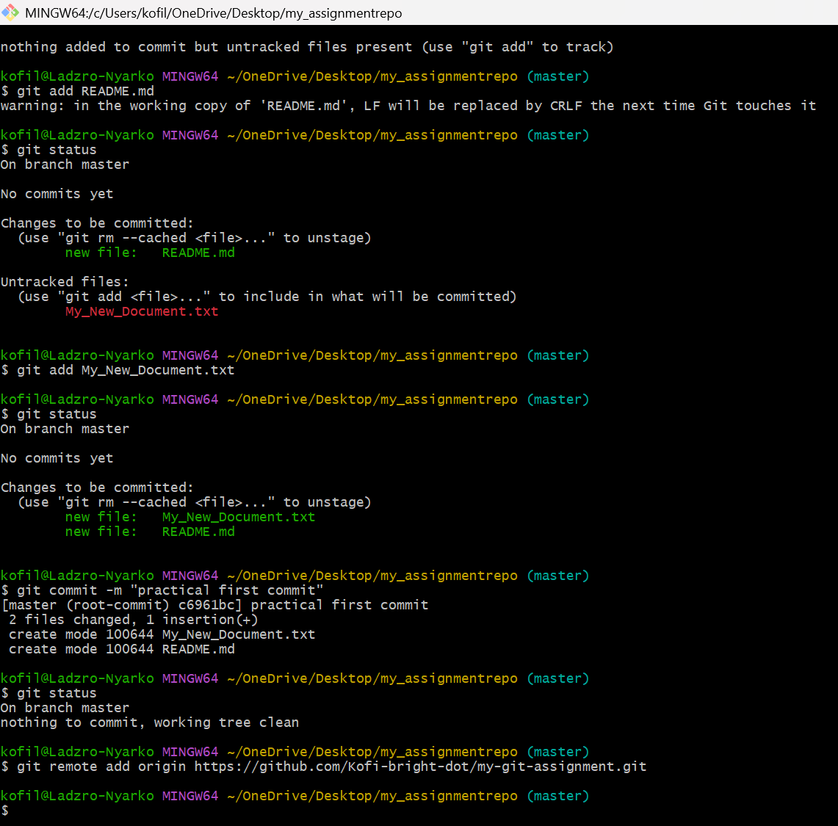

**Executing a push in Git**In Git, pushing refers to the act of transmitting your local commits to a remote repository (e.g., GitHub, GitLab, or Bitbucket). This enables other team members to view and collaborate on your modifications.

**My Repository link**

https://github.com/Kofi-bright-dot/my-git-assignment